Soundbite.AI – Architecture & Security
This document describes the underlying technical considerations in the Soundbite platform for security, compliance, data sovereignty, and other governance considerations.

Introduction
Soundbite is a SaaS platform for recording, listening, and distributing audio in enterprise collaboration scenarios. It’s a combination of secure platform (back-end), client SDK (front-end), and vertical-focused applications that deliver value to our customers by cutting down meeting time and cost by 67% or more.
Soundbite is built with a decade of cloud technology knowledge, an approach emphasizing defense-in-depth, and the security backing of Microsoft.
For more information of Microsoft’s approach to security, privacy, compliance, and transparency in their cloud services, please visit the Microsoft Trust Center. For a full list of compliance capabilities in Microsoft Azure that are harnessed by Soundbite, including operations on Government Regions, check out Microsoft Azure Compliance.

Architecture
The platform is deployed on Microsoft Azure with a “born-in-the-cloud” approach focused on leverage best-in-breed Azure features to deliver scalability and security. The components and technologies are as follows:
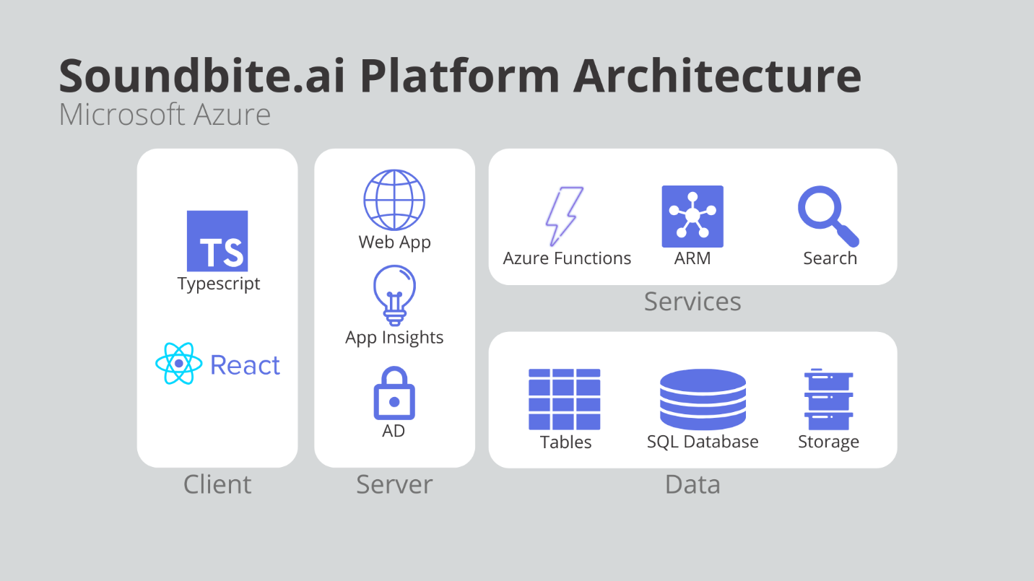

Client
The front-end of the application is built in Typescript and React, consuming an SDK to connect to the Soundbite platform. They also integrate with Microsoft Teams via the SharePoint Framework (SPFx), enabling the Soundbite user experience to be consumed across organizations through easy installation as a tab and bot.
Front-end security considerations include preventing Cross-Site Scripting (XSS) attacks by sanitizing user inputs (such as the prompts displayed when a user sets up a meeting). No use of eval on data, CORS header checking, and no caching of PII are examples of other key security best practices in the front-end.

Server
The back-end application is a C# ASP.Net Core web application running on Azure’s PaaS platform: Web App. This provides easily managed horizontal and vertical scale, plus integration with the real-time telemetry capabilities of Azure Monitor (formerly App Insights), thus powering uptime monitoring, failure reporting, and user behavior tracking.
Finally, Azure Active Directory (AD) provides authentication, authorization, and group metadata to Soundbite via Microsoft Graph. This means a user’s Soundbite identity is conveniently the same for Soundbite as when they are accessing Office 365. On the security side, this means the Soundbite app connects to AD based on Global Admin’s permission and a clear contract on what is available to the platform.
Security concerns in the back-end includes hiding of raw exceptions to conceal error information. Addressing cross-site request forgery through use of anti-forgery tokens and preventing SQL Injection attack through use of parameterized queries and Entity Framework. Finally, security in the REST API, including token management and content validation, addresses vulnerabilities on the web server.

Services
Supporting services in the cloud provide a scalable backbone for delivering features to Soundbite users. Extended API features, such as the polling for messages to send to users about upcoming meetings, are provided via Azure’s serverless compute capability, Azure Functions. Additionally, the elastic infrastructure of the service – which scales instances relevant to organizations joining the platform – is orchestrated via Azure Resource Manager (ARM). Backing the user’s ability to delve into spoken content is the AI-infused Azure Cognitive Search.
All of these services follow the same server-side best practices as resources in the previous section.

Data
The persistence layer in Soundbite is a combination of technologies. Each one is geo-redundant, but chosen for its unique properties to support features requiring their unique capabilities. For instance, Azure Table Storage captures the audit data necessary to provide the last A in AAA (Authentication, Authorization, Accounting). Azure SQL Database provides the foundational persistence of activity on the platform, from shadowing some information from AD for read performance through to tracking and reporting on listens for users. Finally, Azure (Blob) Storage stores the large audio files that users record and listen to while doing their meetings.
Storage accounts (Table and Blob) and SQL instances are one-per-organization, providing data segregation for each client. The SQL database is geo-redundant with a secondary in another region (except where prevented by data privacy, see below) and supports 30-day point-in-time restore with a long-term retention policy for 3 years. Table and Blob data is retained indefinitely and supported the Geo-Redundant Storage (GRS) configuration. Both storage types are encrypted at rest and in transport. Connection strings and other keys are stored either securely in the service itself or centralized into Azure Key Vault. Access to data is always in a least-privilege context based on the cloud component doing work on the data, including read-only accounts for SQL Databases and use of SAS tokens when accessing storage.

Disaster Recovery Plan (DRP)
While our chosen use of largely managed services and PaaS capabilities means individual hardware failures are abstracted away, it’s still possible for a whole tenant or region to be lost due to corruption or catastrophe. In this event, we have the following recourse:
- Active monitoring on the applications and of Azure itself to immediately alert Soundbite support and DevOps to any disruption of service.
- Backup, versioning, and retention such that we maintain point-in-time restore for 30 days with long-term retention of 3 years
- A detailed remediation plan to diagnosis and recover both tenants and regions based on an understanding of their components and configuration.
- A detailed recovery plan that, in the event of outage, corruption, or loss, enables restoring tenants or regions from backup (EG, running from secondary SQL databases, GRS failover for storage)
- A process for automation restoration and migration of a tenant instance in the event a tenant is corrupted or lost in a process taking less than 4 hours
- A process for automated restoration and migration of all tenants in a region to another operable region in the event an entire virtual datacenter fails to come back online in 24 hours

Security Incident Response
The following are key work areas when responding to a security incident. The roles and responsibilities on the team should include both technical resources with sufficient knowledge to identify, contain, and investigate, plus business-focused resources with the knowledge and skill to handle communication. They should work together to review and improve the entire process.
- Identify and report the incident: The first step is to identify that an incident has occurred and report it to the appropriate parties, such as your security team or Azure support. This could be done through an incident response tool or by contacting the relevant parties directly.
- Contain the incident: Once the incident has been reported, the next step is to contain it. This might involve disabling affected systems or limiting access to certain resources to prevent further damage. In some cases, it may be necessary to take the affected systems offline entirely.
- Investigate the incident: With the incident contained, it's time to investigate what happened. This could involve examining logs and other data sources to determine the scope of the incident, how it occurred, and what data was affected.
- Assess the impact: Based on the investigation, you'll need to assess the impact of the incident. This could include identifying what data was compromised and what systems were affected, as well as any potential legal or regulatory implications.
Remediate the incident: Once you have a clear understanding of the incident and its impact, you'll need to remediate it. This could involve patching vulnerabilities, restoring data from backups, or taking other steps to ensure that the incident doesn't happen again.
- Communicate with stakeholders: Throughout the incident response process, it's important to communicate with stakeholders, such as customers or partners. This could involve notifying them of the incident, providing regular updates on the status of the response, and offering guidance on how they can protect themselves.
- Review and improve: Once the incident has been resolved, it's important to conduct a review to identify what went well and what could be improved. This could include reviewing incident response procedures, examining security controls, and implementing changes to prevent similar incidents from occurring in the future.

Personally Identifiable Information (PII)
Unique user information (EG, Full name, home address, email address, social security number, passport number, driver’s license number, credit card number, date of birth, telephone number, login details, etc) may exist in Soundbite’s software or data, along with partially identifiable information (first or last name, country, state, city, postcode, gender, race, age range, job position, workplace, etc). This data will be handled using best practices, including not storing where possible, anonymizing where possible, encrypting always, and ensuring more than one component of the system must be compromised before the information would be human-readable.
In accordance with GDPR, owners will be notified of any known breach of PII data in the Soundbite platform within 72 hours.

Data Sovereignty
Data persisted in Soundbite is captured in the Azure region associated with a country. When organizations are onboarded into the platform, they select a region from Azure’s ever-growing list of locations, including a safe fallback location for geo-redundancy of their SQL Database. This ensures they are in control of the jurisdiction for their data.

Legal
By accessing Soundbite, you agree to be bound by our Terms and Conditions.
There are a number of US Federal Laws that protect personal privacy in electronic communications. The Soundbite Privacy Policy information you regarding the collection, use, and disclosure of personal information in the service. Soundbite will not use or share your information with anyone except as described in the Privacy Policy.
Additionally, the Soundbite End-User License Agreement (EULA) can be found here: Soundbite EULA.

Conclusion
Soundbite provides an enterprise-grade collaboration solution for saving your teams time while maintaining security best practices. Our deep integration into the Microsoft ecosystem provides not only the tools, but the trust necessary to get the job done for some of the world’s biggest companies.
If you have more questions, please email Support@Soundbite.ai

